Inquiry: Sumatran earthquakes with GPS
Earth Science Education
www.earthobservatory.sg

Preparation: Before doing this investigation, complete two introductory investigations using GPS data from UNAVCO (http://www.unavco.org/edu_outreach/):

Introduction to reading GPS time series plots
http://cws.unavco.org:8080/cws/modules/readingGPStimeseries

Exploring plate motion and deformation in California using GPS time series
http://cws.unavco.org:8080/cws/modules/GPStimeseriesCA/

Sumatran earthquakes

Maritime Southeast Asia is encircled by plate boundaries (Figure 1). The Eurasian plate includes mainland Asia, Sumatra, Java and Borneo. To the southwest of Sumatra lies the Indo-Australian plate, which subducts under the Eurasian plate (Figure 2). This boundary between Indo-Australian and Eurasia has had numerous major earthquakes in historical times (Figure 3), including the December 2004 magnitude (M) 9.2 earthquake that produced a tsunami which swept across the Indian Ocean, killing more than 250,000 people.

In this exercise, we will focus on Sumatra. The Sumatran GPS Array (SuGAr) records deformation along the plate boundary between the two plates and helps us better understand the earthquake and tsunami hazards in the region (Figure 4).

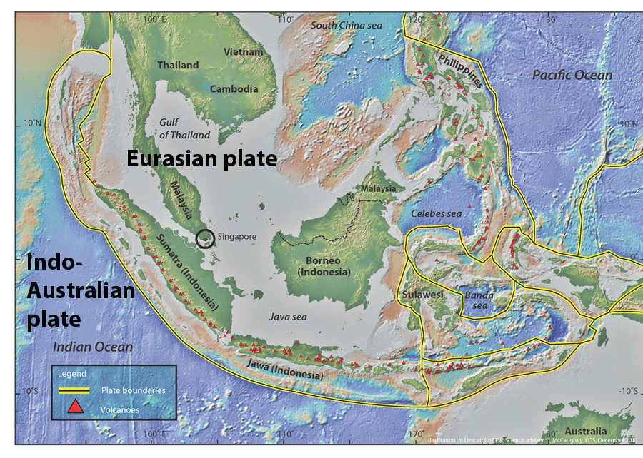
Figure 1. Southeast Asia, tectonic setting.

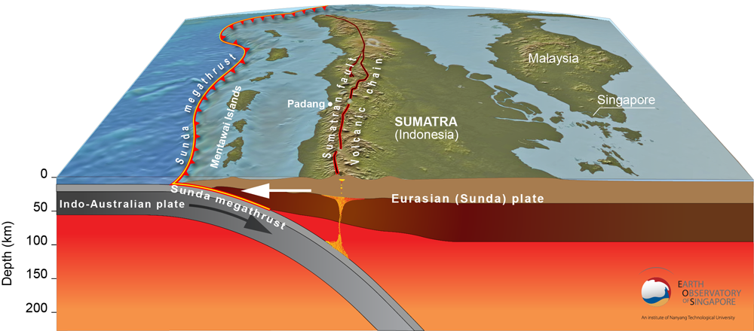

Figure 2. Sumatran subduction zone.

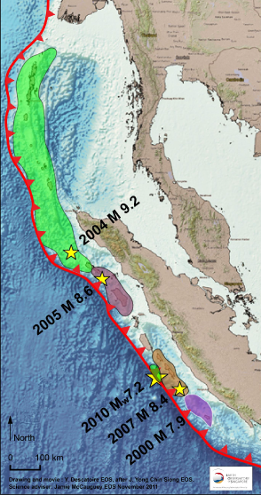
Figure 3. Recent major earthquakes on the Sunda megathrust, the plate-boundary fault between the Eurasian and Indo-Australian plates. Each colored patch represents the rupture patch of the earthquake, which is the portion of the fault that slipped in the earthquake. Strong shaking and tsunamis extended far beyond these rupture patches.

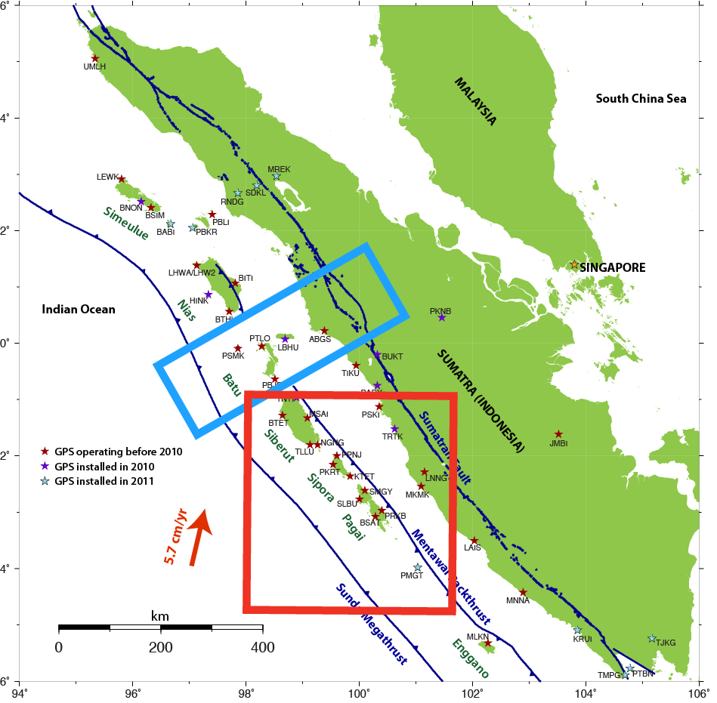

Figure 4. SuGAr: the Sumatran GPS Array, a collaboration of the Indonesian Institute of Sciences (LIPI), the Earth Observatory of Singapore (EOS), and Caltech. Stars mark GPS stations; blue lines indicate major faults. Red box shows location of Figure 6; blue box shows location of Figures 9 and 10.

Part 1. High-rate GPS measurements of the 25-Oct-2010 Mentawai earthquake

On 25-Oct-2010, the SuGAr network recorded an earthquake near the Mentawai Islands with high-rate (1-second) data (Figure 5).

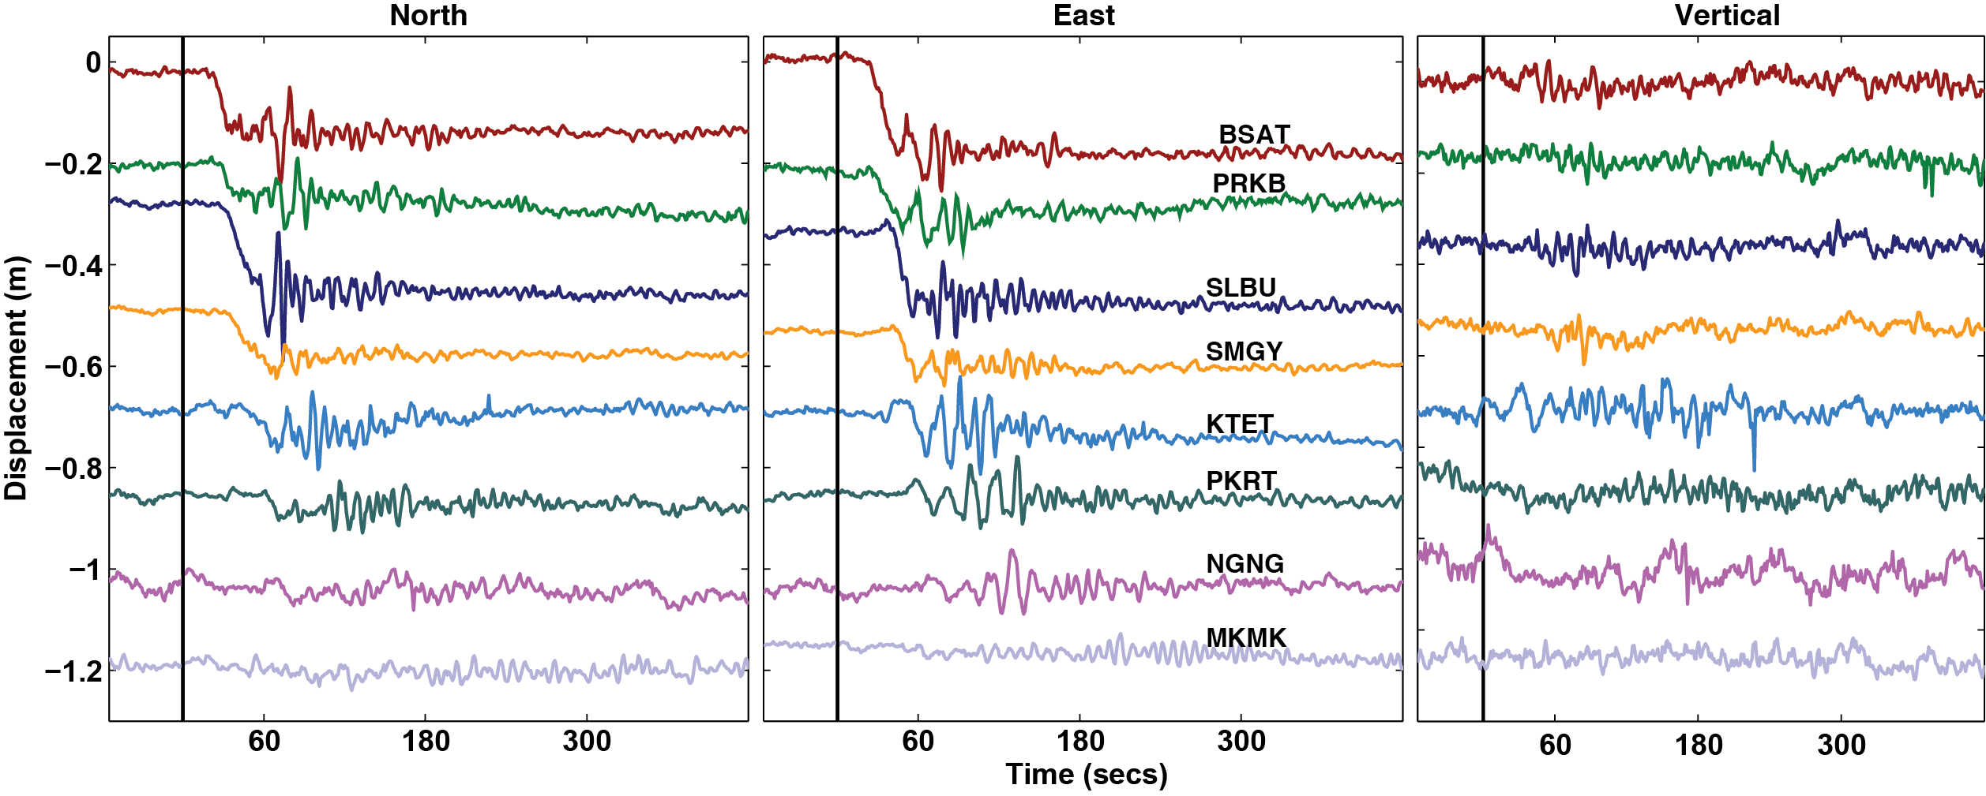
Figure 5. GPS time series, 1-second data, for 25-Oct-2010 Mentawai earthquake, after Hill et al. (2012). The vertical black line is the time of the earthquake (t=0). Stations are ordered roughly from south to north (locations on Figure 6). Each time series is arbitrarily offset along the y-axis for clarity.

Question 1) Describe the patterns that you can see in the data. What can we infer about the earthquake from this data?

Question 2) Plot vectors of the earthquake displacement for stations BSAT, SLBU, and PKRT on Figure 6, using the GPS data depicted on Figure 3. Use a scale of 0.1 m displacement = 2 cm on the page. It may help to sketch out north-south and east-west vectors separately and then use them to determine the overall horizontal motion graphically. Also mark your estimate of the earthquake epicenter on Figure 6.

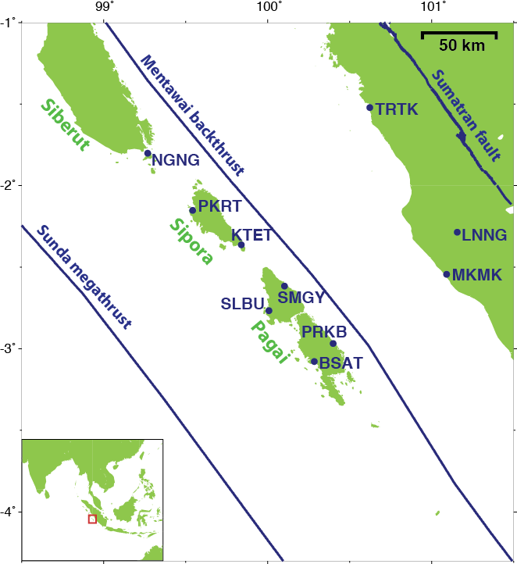
Figure 6. Mentawai Islands, with SuGAr stations.

Part 2: A tale of two earthquakes

We will look at a longer time series from one station: BSAT, in the village of Bulasat on the west coast of South Pagai Island (Figures 6 and 7).

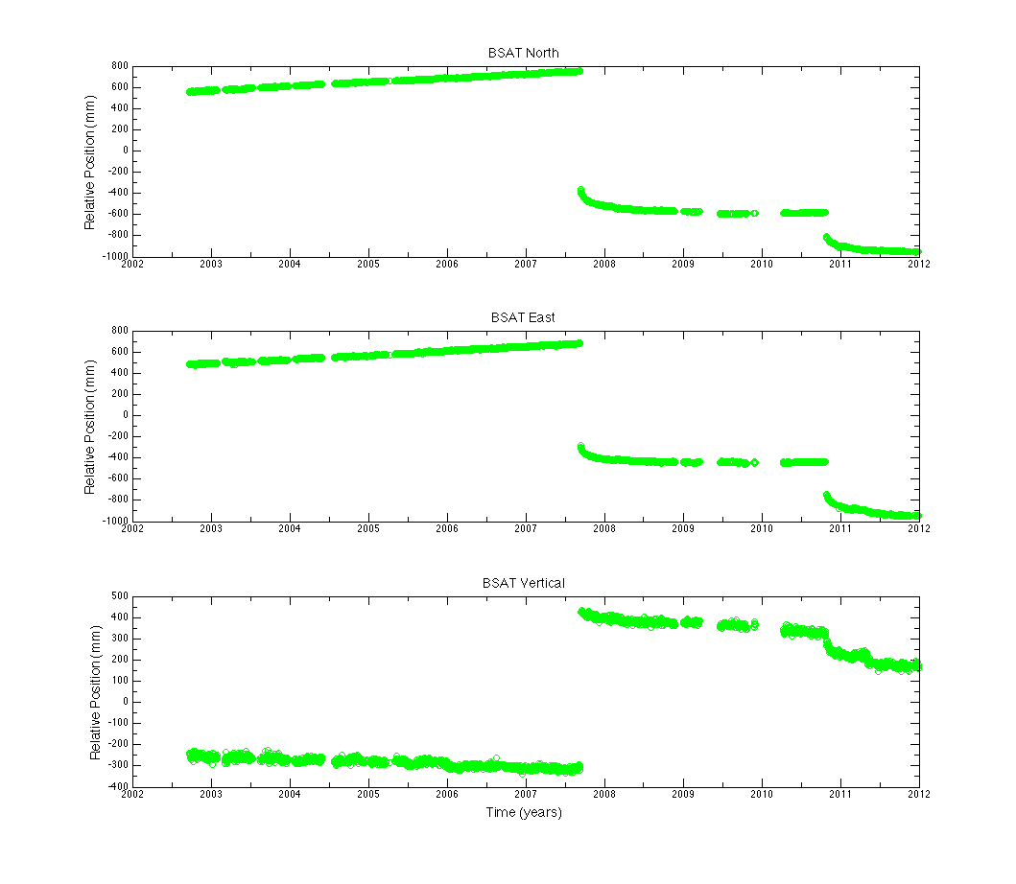
Figure 7. GPS time series for station BSAT, courtesy Lujia Feng.

Question 3) What do the horizontal spaces represent (such as around the beginning of 2010)?

Question 4) How many major earthquakes can you identify in the time series? For each, estimate the date, horizontal displacement and direction, and vertical displacement and direction.

Question 5) The sources of both of these earthquakes were close to this station. One earthquake was M (magnitude) 7.8, while the other was M 8.4. One earthquake caused a 4m tsunami, while the other caused a 17m tsunami. Which do you think is which? Refer also to Figure 8.

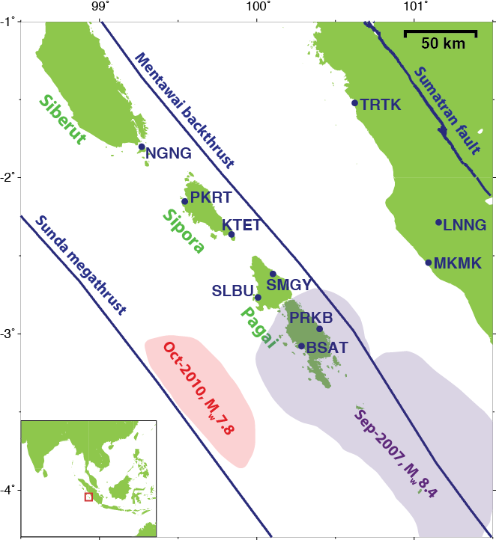

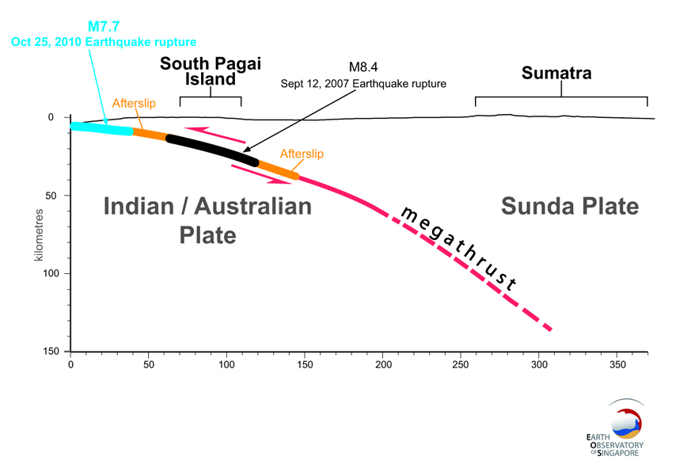

Figure 8. Relation of Sep-2007 and Oct-2010 rupture patches on the Sunda megathrust, the plate-boundary fault, in map view (left) and cross-sectional view (right).

Part 3. Plate motion: building up to a large earthquake?

First, watch this animation:

Subduction GPS evidence (from IRIS)
http://www.youtube.com/watch?v=XqXxJzVsQq4

Question 6) Mark the location of the blue box from Figure 4 on the block diagram in Figure 3. Also add a north arrow to the top of the block.

Question 7) Looking carefully at the latitude and longitude markings, draw a North arrow on Figures 9 and 10.

Figure 9. Horizontal rates, for the past few years, of background motion with earthquakes subtracted out. This is the slow, long-term motion, not the sudden shift during an earthquake. (Figure by Lujia Feng)

Question 8) Describe the pattern you see in the horizontal rates (Figure 9). Make a hypothesis that may explain this pattern.

Figure 10. Vertical rates, for the past few years, of background motion with earthquakes subtracted out. This is the slow, long-term motion, not the sudden shift during an earthquake. (Figure by Lujia Feng)

Question 9) Describe the pattern that you see in the vertical rates (Figure 10). Make a hypothesis that may explain this pattern.

Question 10) Watch this cartoon animation of plate motion in Sumatra. Does the data above (questions 8 and 9) provide evidence for the kind of motion shown in the animation, or does it contradict it? Explain.

Earthquakes and tsunami in Sumatra (from Caltech)
http://www.youtube.com/watch?v=Hs5plIrCmWM

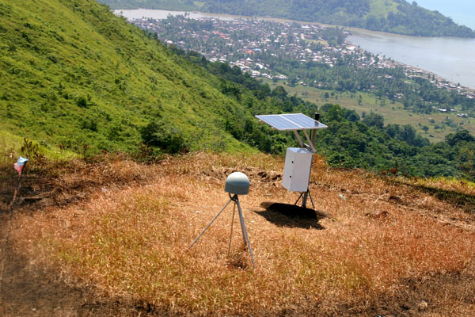
Figure 11. GPS station at Air Bangis, West Sumatra, with the coastal community of Air Bangis in the distance.

Question 11) Look at Figure 11. From the evidence you have examined in this exercise, what hazards do the people of Air Bangis face? What preparations can they make to reduce their vulnerability to these hazards?

Reference:
Hill, E. M., et al. (2012), The 2010 Mw 7.8 Mentawai earthquake: Very shallow source of a rare tsunami earthquake determined from tsunami field survey and near-field GPS data, J. Geophys. Res., 117, B06402, doi:10.1029/2012JB009159.

